Step 1: Train and Save the Model

From your Jupyter Notebook, you need to ensure that the sentiment analysis model and the TF-IDF vectorizer are trained and saved so that Flask can load them.

Step 2:

how to run the app.py file:

ensure that the flask joblib scikit-learn are installed in your system

If it is not installed in system then run in whatever u are using like vs code or collab or pycharm terminal by using: 1) pip install flask

2)pip install joblib

3)pip install scikit-learn

Once the project structure is set, and you have created app.py, you can run the Flask app.

Open a terminal or command prompt and run as shown in figure

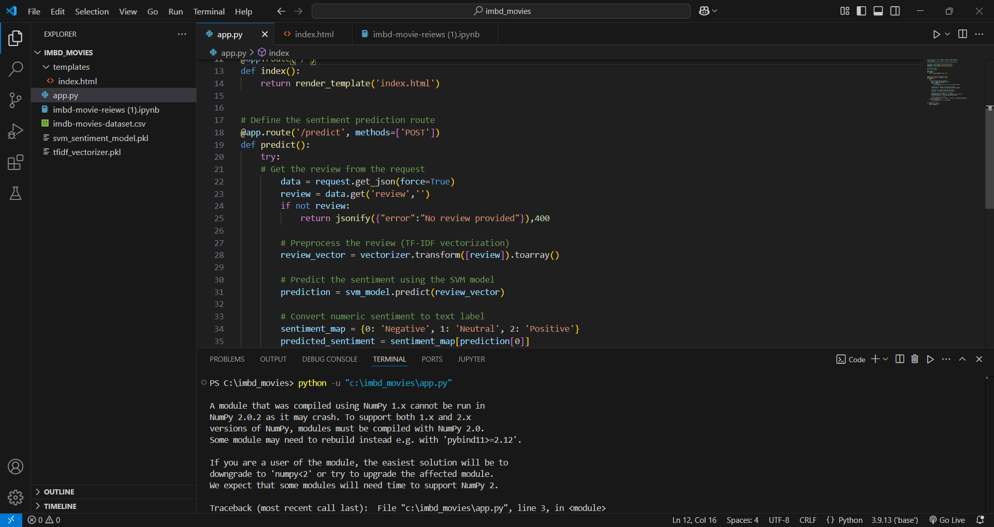

After that the link is generated like

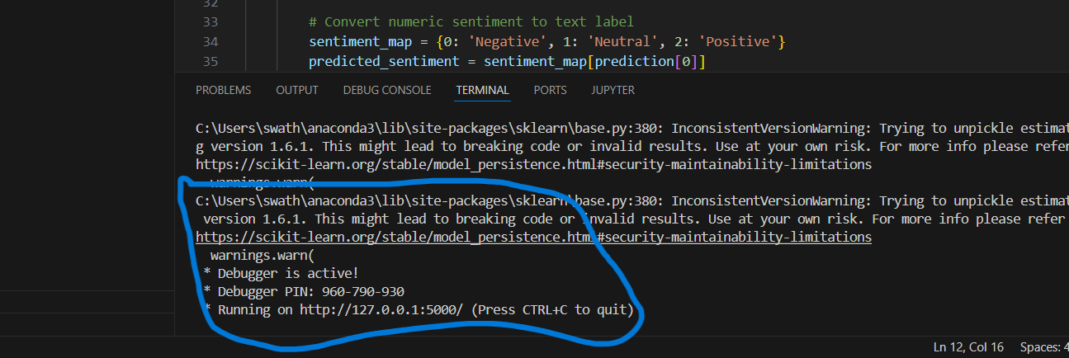

Click on the link the output will be

